**Week 7 Homework: A Day in the Life of a Windows Sysadmin**

**Task1: Screenshot of all GPOs**

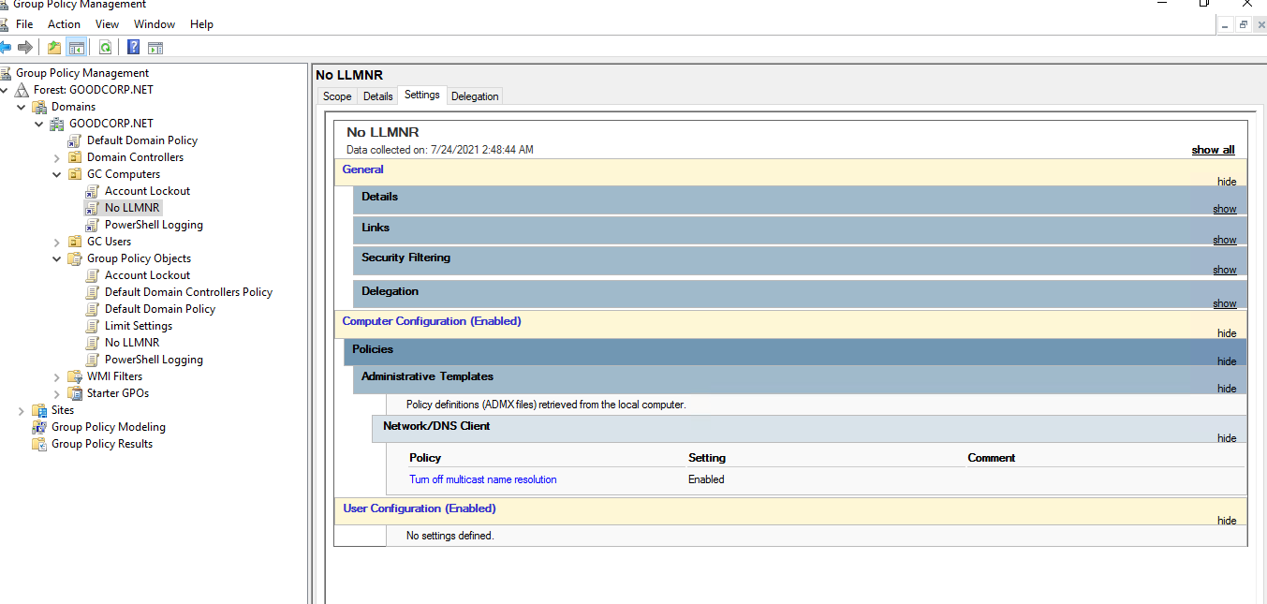

**Task2: GPO: Account Lockout**

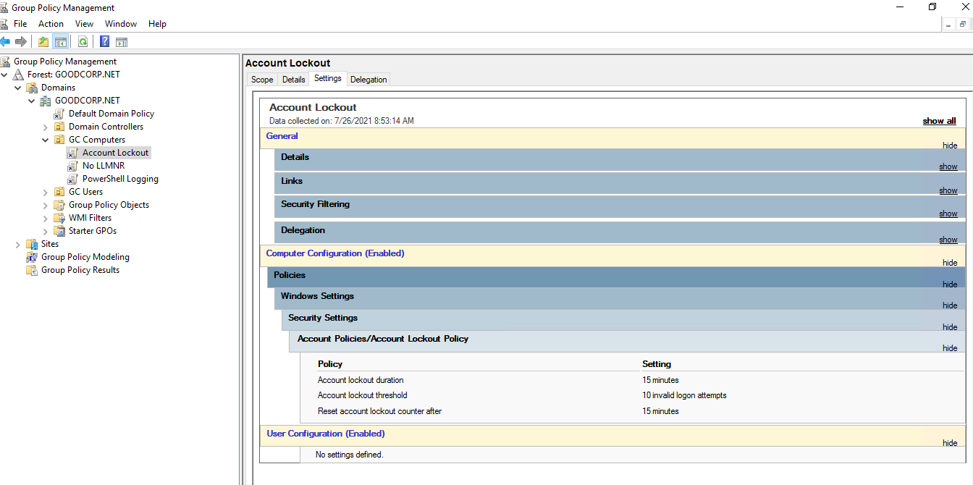

**Task3: GPO: Powershell Logging and Transcription**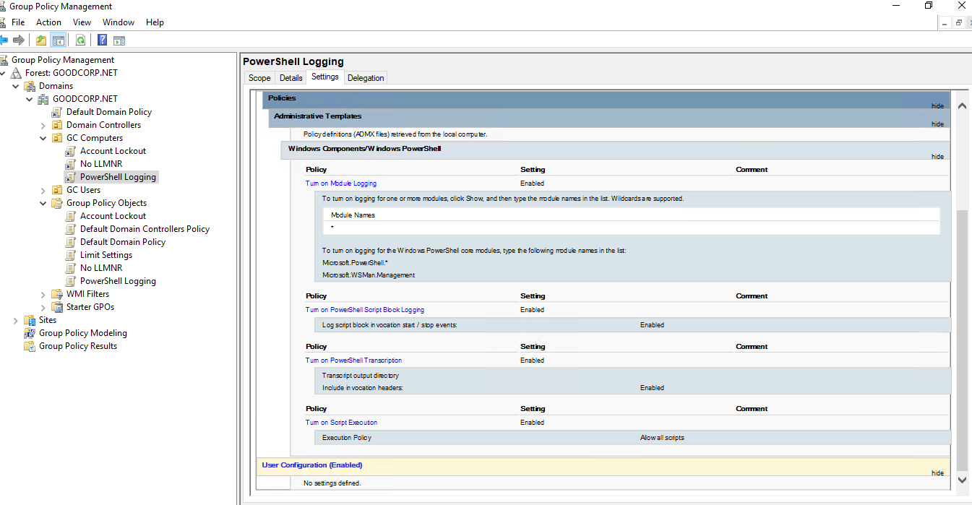

**Task 4: Script: enumerate ACLs**

# Get child objects and store them in a variable

$directory = Get-ChildItem

# loop through all the child objects to get the acl for each of them

foreach ($item in $directory) {

Get-Acl $item

}

**Output:**

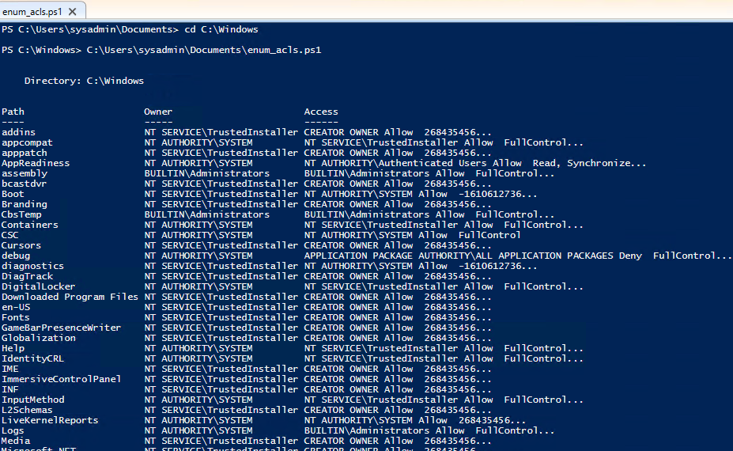

**Task 5: Verify Powershell Logging GPO**

